- Our Strategy for R2RML Mapping Generation
  - Overview
In this section, we present our approach for the automatic generation of customized R2RML mappings.
The process inputs are:
- D = (V_{D},C_{D}): the domain ontology
- S: the data source schema that must be mapped to D
- A: a set of correspondence assertions between S and D
As shown in Figure 3, the mapping generation process consists of two main steps. The first step involves the design of the exported ontology E = (V_{E},C_{E}), which models the RDF view exported by the data source. The vocabulary V_{E} of the exported ontology is a subset of V_{D}, which can be automatically generated based on the matching assertions between the D and S [12].
The second step involves the design of: (i) a set of relational view schemas VS, where VS is a direct transformation for the exported ontology E; and (ii) a R2RML mapping M which maps VS to E. The views schemas in VS can be implemented as SQL views or R2RML views. In Section 4.2, we present an algorithm that automatically generates VS and M from the process inputs.
The benefits of using relational views as a middle layer are twofold: (i) given that VS is a direct transformation of E, the mapping M can be automatically generated based on VS; (ii) it becomes easier to change the R2RML mapping M to accommodate changes to the database view schemas.
  - Step 1: Design of the Exported Ontology
The design of the exported ontology depends on what we require from the data exported by the data source. As proposed in [xx], we require the exported ontology be an open or a closed fragment of the domain ontology.
Again, let D = (V_{D},C_{D}) denote the domain ontology and E = (V_{E},C_{E}) denote the exported ontology. Assume that V_{E} is a subset of V_{D}. Then, E = (V_{E},C_{E}) can be automatically generated, based on the correspondence assertions between the D and S [xx]. Briefly, a term T (class or property) of V_{D} is in V_{E} if and only if there is a matching assertion for T in A. The constraints C_{E} are generated using the procedure openFragment introduced in [xx].
Consider, for example, the ISWC_REL database schema in Figure 1, the CONF_OWL Domain Ontology in Figure 2 and the correspondence assertions in Table 3. Figure 4 shows the exported ontology ISWC_RDF. The vocabulary of ISWC_RDF contains all the elements of the ISWC ontology that matches an element of ISWS_REL. The constraints are generated using the procedure openFragment introduced in [xx].

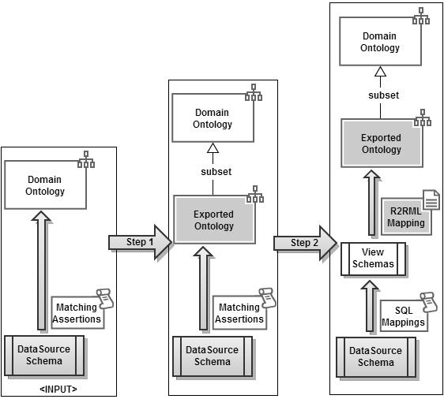
Fig. 3. R2RML Mapping Generation Process

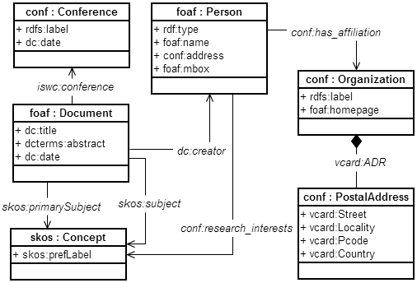
Fig. 4. ISWC_RDF Exported Ontology Schema
  - Step 2: Design of relational view schemas and R2RML mappings

Table 9 shows Algorithm 1, which automatically generates the relational view schemas and R2RML mappings for a given exported ontology E = (V_{E},C_{E}). The algorithm has 3 main steps:
Step 1: For each class in V_{E}, create a relational view and the CCA that matches the class with the view.
Step 2: Deals with datatype properties in V_{E}. Two cases are possible:
- Case 2.1. If the datatype property has maxcardinality equal to 1, generate an attribute and a DCA that matches the datatype property with the attribute.
- Case 2.2. If the datatype property has maxcardinality greater than1, generate a link relation with a foreign key and an attribute, and generate a DCA that matches the datatype property with a path composed by the foreign key and the attribute.
Step 3: Deals with object properties in V_{E}. Two cases are possible:
- Case 2.1. If the object property has maxcardinality equal to 1, generate a foreign key and an OCA that matches the datatype property with the foreign key.
- Case 2.2. If the object property has maxcardinality greater than1, generate a link relation with two foreign keys and the OCA that matches the datatype property with a path composed by the two foreign keys.

Figure 5 depicts ISWC_Views, the relational view schemas for the exported ontology ISWC_RDF, and Table 10 contains some of the CAs between the ISWC_RDF vocabulary and ISWC_Views.
In Figure 5, the relations Conference, Person, Document, Concept, Organization and PostalAddress are generated for the classes in ISWC_RDF; and the link relations Document_Creator, Document_Subject, Person_ResearchInterests, Person_hasAfilliation are generated for the object properties Creator, Subject, ResearchInterests, hasAfilliation respectively.
In Figure xx: line the subject
Table 11 contains some of the R2RML mappings automatically generated from the CAs in Table 10, as discussed in Section 4.
Table 9. Algorithm 1
Input: Exported Ontology E = (V_{E},C_{E})
Output: a set VS of relational view schemas and R2RML mappings between VS and E.
Step 1: For each class pc:C in V_{E} do
Create a relational view C;
Create attribute ID as primary key of C;
Create CCA pc:C ≡ C[ID];
Step 2: For each datatype property pp:P in V_{E} do
Let pd:D be the domain of pp:P;

Case 2.1: pp:P has maxCardinality equal to 1.
Create attribute P in view D whose type is defined according to range of pp:P;
Create DCA pp:P ≡ D/P;
Case 2.2: pp:P has maxCardinality greater than 1.
Create intermediate relational view D_P;
Create attribute ID_D in D_P defined as a foreign key to D (parent table);
Create attribute P in D_P whose type is defined according to range of pp:P;
- Create DCA pp:P ≡ D/[ID_D]/P;
Step 3: For each object property pp:P in V_{E} do
Let pd:D and pr:R be the domain and range of pp:P, respectively;

Case 3.1: pp:P has maxCardinality equal to 1.
Create attribute ID_R in table D which is a foreign key to R (parent table);
Create OCA pp:P ≡ D/[ID_R];
Case 3.2: pp:P has maxCardinality greater than 1.
Create intermediate table D_P;
Create attribute ID_D in D_P which is a foreign key to D;
Create attribute ID_R in D_P which is a foreign key to R;
Create OCA pp:P ≡ D/[ID_D, ID_R];
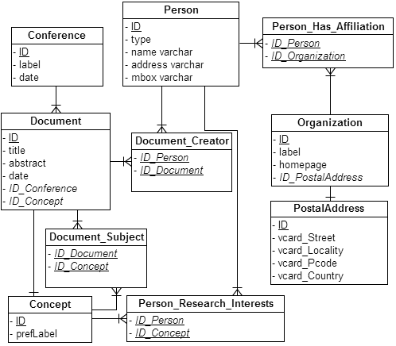
Fig. 5. ISWC_View Schemas
Table 10. Correspondence Assertions between the ISWC_RDF vocabulary and ISWC_Views
CCA1 | foaf:Person ≡ Person[ID]
CCA2 | foaf:Document ≡ Document[ID]
CCA3 | conf:Organization ≡ Organization[ID]
CCA4 | conf:PostalAddress ≡ PostalAddress[ID]
CCA5 | conf:Conference ≡ Conference[ID]
CCA6 | skos:Concept ≡ Topics_Rel[ID]
OCA1 | conf:has_affiliation ≡ Persons /{ID_Person, ID_Organization}
OCA2 | conf:has_research_interests ≡ Persons /{ID_Person, ID_Concept}
OCA3 | vcard:ADR ≡ Organization /{ID_PostalAddress}
OCA4 | skos:Subjec ≡ Document /{ID_Document, ID_Concept}
OCA5 | conf:Conference ≡ Document / {ID_Conference}
OCA6 | skos:broader ≡ Topics_Rel / has_broader
DCA1 | foaf:name ≡ Persons / name
DCA2 | conf:address ≡ Persons / address

Table 1. R2RML Mapping Generated.
123 | <#PersonTriplesMap>  rr:logicalTable [ rr:tableName "Person" ];  rr:subjectMap [  rr:template "http://example.com/person/{id}";  rr:class foaf:Person;  ];
2 | rr:predicateObjectMap [  rr:predicate foaf:mbox;  rr:objectMap [ rr:column "mbox" ];  ];
3 | ...
4 | <#ConceptTriplesMap>  rr:logicalTable [ rr:tableName "Concept" ];  rr:subjectMap [  rr:template "http://example.com/concept/{id}";  rr:class skos:Concept;  ];
5 | rr:predicateObjectMap [  rr:predicate skos:prefLabel;  rr:objectMap [ rr:column "prefLabel" ];  ];
6 | ...
7 | <#Person_Research_InterestsTriplesMap>  rr:logicalTable [  rr:tableName “Person_Research_Interests”  ];  rr:subjectMap [  rr:template "http://example.com/person/{id_person}";  ];  rr:predicateObjectMap [  rr:predicate iswc:research_interests;  rr:objectMap [  rr:template "http:// example.com/concept /{id_concept}";  ];  ];  ].

